   PATTY HALL  

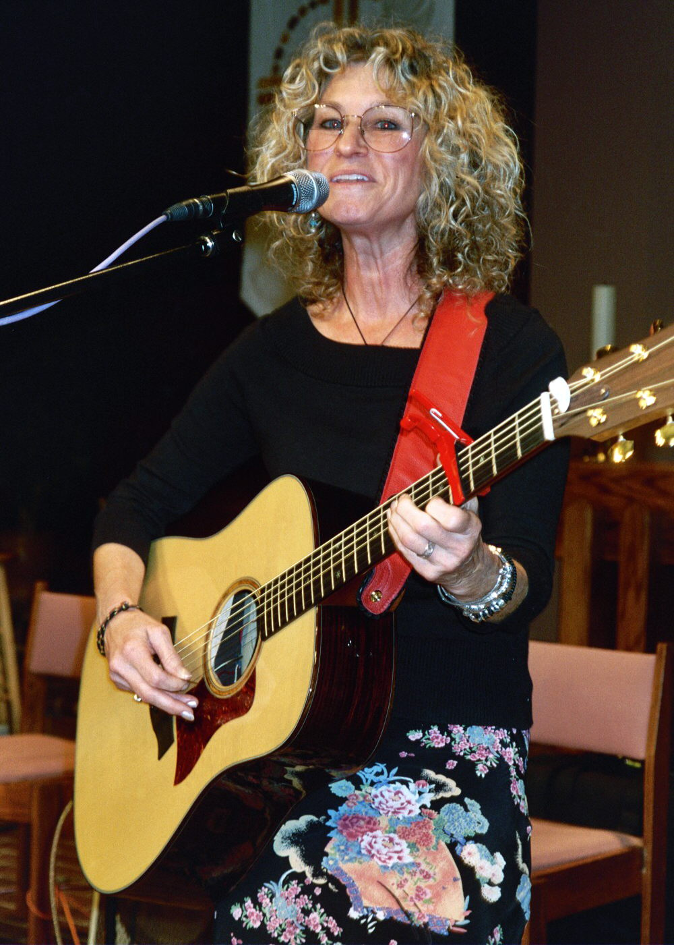

NATIVE DAUGHTER OF THE GOLDEN WEST™

TUESDAY, JANUARY 4, 2005
NORTH COUNTY FOLK & BLUEGRASS CLUB
ROUNDTABLE PIZZA – ESCONDIDO, CA
7:00 – 10:00 PM

1161 East Washington
(corner of Ash and East Washington)
Escondido, CA   

Come on out to ROUNDTABLE PIZZA in ESCONDIDO to hear singer/ songwriter/folklorist/author PATTY HALL share some of her NATIVE DAUGHTER™ songs. Patty will be backed by LES and LOU ANN PRESTON, MARK FOXWORTHY, and BETH MOSKO (featured musicians on her forthcoming CD, JUST BE GLAD). Also on the bill are some of San Diego’s finest bluegrass and folk musicians.

For more information call (760) 726-8380 or (760) 489-0191

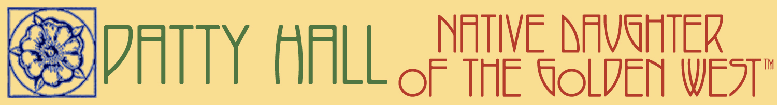
www.pattyhall.com

